Computer Aided Lab A

Name of Student:

Le Hoang Khang

Nguyen Phuong Tu Anh

Mentor:

10.30. – 11.20.2024

Contents

Introduction 3

1 Theoritical part 3

1.1 RC low pass filter 3

1.2 Charging and Discharging of Capacitor 3

1.3 Operational amplifier 3

1.3.1 Operational Amplifier Terminals 3

1.3.2 Inverting operational amplifier 3

1.3.3 Integrating operational amplifier 3

1.3.4 Derivating opeartional ampliefier 3

1.3.5 Adding operational amplifier 3

2 Experiment 3

2.1 Measurement of exp 1 3

2.1.1 Description of experiment 3

2.1.2 Results – diagram, table, graphics 3

2.1.3 3.1.3. Discussion of results 3

2.2 Measurement of exp 1 3

2.2.1 Description of experiment 3

2.2.2 Results – diagram, table, graphics 3

2.2.3 Discussion of results 3

2.3 Measurement of exp 3 3

2.3.1 Description of experiment 3

2.3.2 Results – diagram, table, graphics 3

2.3.3 3.1.3. Discussion of results 4

3 Summary and Outlook 4

4 References 4

# 

# **Introduction**

## **Theoritical part**

## **RC low pass filter [2]:**

Em có thể cho anh 1 – 2 câu gt về low pass filter đc hem nè

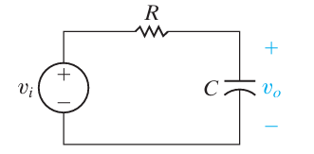

Figure 1

Figure 1: A series RC low-pass filter [2]

The series RC circuit shown in Figure 1 behaves as a low-pass filter. In the low-pass filter circuit, three frequency regions are used to develop of the series RC circuit in Figure 1.

* Zero frequency (ꞷ should be f = 0): The impedance of the capacitor is infinite and the capacitor acts as an open circuit. The input and output voltages are the same.
* Frequencies increasing from zero: The impedance of the capacitor decreases relative to the impedance of the resistor, and the source voltage divides between the resistive impedance and the capacitive impedance. The output voltage is thus smaller than the source voltage.
* Infinite frequency (ꞷ should be f = ∞): The impedance of the capacitor is zero, and the capacitor acts as a short circuit. The output voltage is thus zero.

**Transfer function between the source voltage and the output voltage:**

To derive an expression for the transfer function, the s-domain equivalent of the circuit is first constructed in Figure 1, as shown in Figure 2.

Using s-domain voltage division on the equivalent circuit, the ratio of the source voltage and the output voltage:

H(s) = (1)

Now, substitute s = jꞷ and compute the magnitude of the resulting complex expression:

(2)

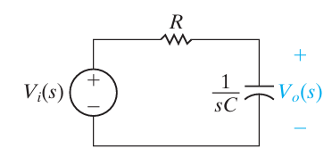

Figure 2

Figure 2: The s-domain equivalent for the circuit in Figure 1

**At the cutoff frequency : =**

For a low-pass filter, and for the circuit in Figure 2, . The relationship among the quantities R, C, and :

= (1) = (3)

* (4)

What is the behave of the signal in low pass filter and where is cut off frequency ???

## **Charging and Discharging of Capacitor [5]**

anh nghĩ cần 1 hình minh họa cho tụ

The voltage of the capacitor at fully charged condition is . The discharging current of the circuit would be (Ampere) when the capacitor is short-circuited. However, When the input voltage is supplied to the RC low-pass filter circuit, the capacitor begins to store charge at t = , the current through the circuit is:

(5)

Where C trong ct 5 là gì á em iu

As per Kirchhoff’s Voltage Law, the relationship between the change of voltage and time is:

(

(6)

R là gì á em iu, dt là gì á em nên giải thích ra kỹ các công thức

Integrating both sides, the logarithm of output voltage value is:

(7)

Where, A is the constant of integration and, at t = 0, v = V, the formular of the discharging of Capacitor (8):

(8)

In this experiment, and :

(8) for (9)

With charging of a capacitor [6], the capacitor begins to store charge. If at any time during charging, I (các ký hiệu nên ghi nghiêng hết nhà cục cưng, em chỉ nghi đứng trong 1 số trường hợp đặc biệt thui) is the current through the circuit and Q is the charge on the capacitor, then the sum of both these potentials is equal to ꜫ

(10)

When :

(11)

From equations (10, 11), the rate of change of this charge is:

(12)

Integrating both sides within proper limits, the formular of the output voltage in time:

(13)

(14)

(15)

For (16)

## **Operational amplifier**

### **Inverting operational amplifier [2]:**

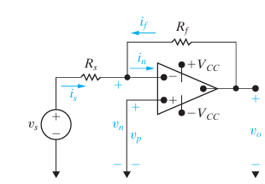

Figure 3

Figure 3: An inverting-amplifier circuit [2]

Figure 3 illustrates an inverting-amplifier circuit. In the inverting-amplifier circuit, the circuit connected between the noninverting input terminal and the common node. To obtain an expression for the output voltage, , as a function of the source voltage, . A single node-voltage equation (node nèo ta mình ký hiệu them vào hình á) at the inverting terminal of the op amp is given as:

(17)

In this inverting op-amp circuit, the constraint on the input voltages of the op amp is: . And the voltage is set at , because the voltage at . Therefore,

(18)

(19)

Ideally, the equivalent input resistance is infinite, resulting in the current constraint:

(20)

Substituting Equations (17, 18, 19, 20) yields the sought-after result:

(21)

Cho anh công thức của gain nha kiểu G = - Rf / Rs á vs them 1 dòng ghi về input vs output signal nha

### **Integrating operational amplifier [2]:**

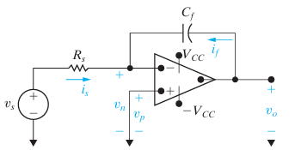

Figure 4

Figure 4: An integrating amplifier [2]

It is assumed that the operational amplifier is ideal:

(22)

(23)

Because ,

(24)

(25)

Hence, from Equations (22, 24, 25, the current flowing through the feedback capacitor C is given as:

(26)

Multiplying both sides of Equations (26) by a differential time dt and then integrating from to t generates the equation

(27)

Equation (27) states that the output voltage of an integrating amplifier equals the initial value of the voltage on the capacitor plus an inverted, scaled replica of the integral of the input voltage. If there is no energy stored in the capacitor the equation (27) reduces to

(28)

Em nhớ canh dòng nha đều 2 bên + đầu dòng cách vào 1 tab nhoa

### **The operational amplifier Differentiator [7]:**

In the Op-Amp Differentiator circuit, the input is the time-varying function and the virtual ground at the inverting input terminal of the op amp causes to appear in effect across the capacitor C. Thus, the current through C will be , and this current flows through the feedback resistor R providing at the op-amp output a voltage

(29)

(30)

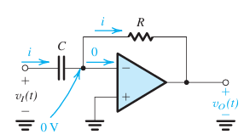

Figure 5

Figure 5: The op-amp differentiator [7]

Anh nghĩ mình sẽ them ở đây 1 tab nữa nói về ideal amplifier để mình nói một chút tại sao có 0 V trong mạch nha cần anh sẽ giải thích them cho em

# **Experiment**

## **Measurement of experiment 1:**

### **Description of experiment 1:**

In this exercise, the fundamental frequency response of an RC low pass filter circuit is analyzed. A low pass filter circuit, consisting of a resistor () and a capacitor (), is constructed and connected to a wave generator and a digital storage oscilloscope (DSO) as shown in the figure below.

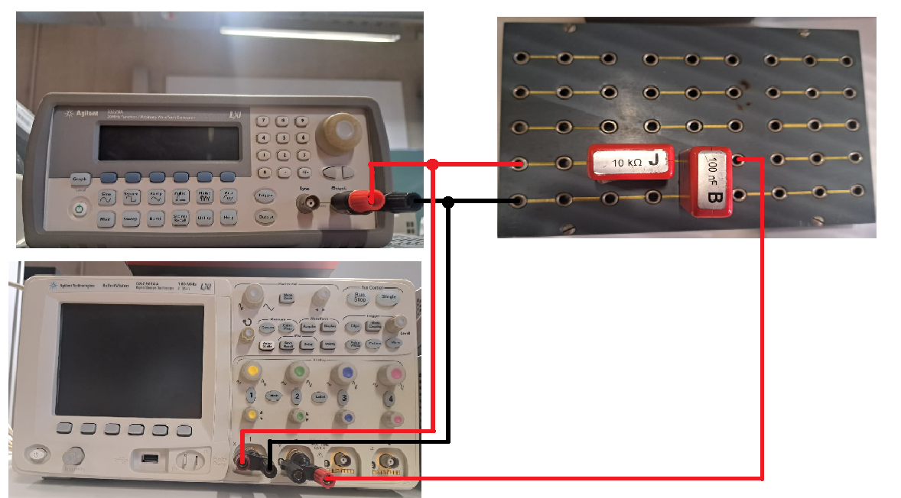

Figure 6: The experiment 1 setup

The wave generator serves as the source, providing varying frequencies and wave types for the exercise, while the oscilloscope captures both the input and output waveforms of the system. Channel 1 of the oscilloscope is connected to both the input of the wave generator and the input of the RC circuit, and Channel 2 is connected to the output of the RC circuit. All grounds for the wave generator, oscilloscope, and RC filter are connected together.

A sine wave input of varying frequency is applied, starting at a low frequency with a peak-to-peak amplitude of 10 V. The frequency is then adjusted to achieve specific amplitude ratios (A) between the input and output, with target ratios of 1, 0.9, 0.8, 0.7, 0.6, 0.5, 0.3, 0.2, and 0.1. The ratio A value is obtained by:

Where is peak to peak voltage of the input wave and is the peak-to-peak voltage of the output wave. Additionally, the phase shift between the input and output signals is measured by DSO tool.

The objective is to observe how the amplitude ratio and phase shift vary as the frequency increases, continuing measurements until the amplitude ratio reaches the specified thresholds. The data is then plotted to illustrate the amplitude ratio and phase shift as functions of frequency. From these plots, the circuit’s cut-off frequency—where the output amplitude falls to approximately 70.7% of the input—is determined and compared with the theoretical value. The phase shift at this cut-off frequency is also recorded.

A sine wave input

### **Results – diagram, table, graphics**

* Calculate the cut of the frequency for the given low pass filter:

Table 1.

|  |  |  |  |  |
| --- | --- | --- | --- | --- |
| **Freq. f (Hz)** |  |  | **A** | **Φ[ͦ ]** |
| 1 | 10 | 10 | 1 | 1 ͦ |
| 98 | 9 | 0.9 | 30 ͦ |
| 125 | 8 | 0.8 | 39 ͦ |
| 171 | 7 | 0.7 | 44 ͦ |
| 235 | 6 | 0.6 | 52 ͦ |
| 301 | 5 | 0.5 | 61 ͦ |
| 432 | 4 | 0.4 | 70 ͦ |
| 808 | 2 | 0.2 | 75 ͦ |
| 1718 | 1 | 0.1 | 78 ͦ |

Table 2

|  |  |
| --- | --- |
| **Determined cut off frequency** | 171 Hz |
| **Phase angle φ at cut off frequency** |  |

* The plot demonstrates the relationship between the output voltage and the frequency of output signal:

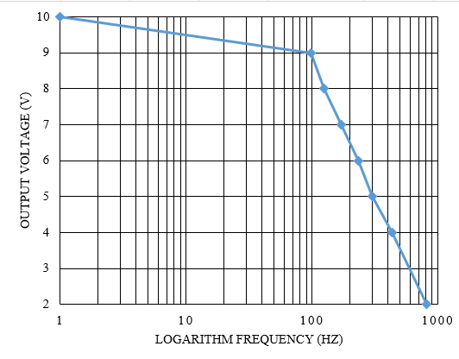

Figure 6

Plot 1: Amplitude ratio A and the logarithm frequency f

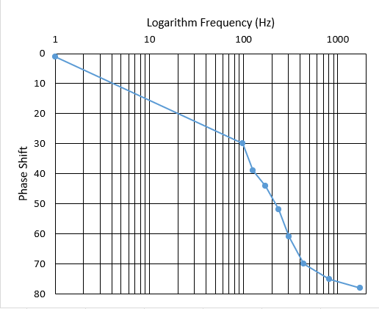

Figure 7

Figure 8.

Plot 2: Phase shift and the logarithm frequency f

### **Discussion of results**

At the cut off frequency , the theoretical output voltage: = 7.07 (V). The cut off frequency measured approximately equal to the frequency at the output voltage 0.707 V. ≈ 159.154 Hz. When the frequency increased, the output voltage value decreased. tThiếu câu trả ời nè phase là nhiu á em iu em nên nói là dựa trên các figure và kết quả đo thí nghiệm nè

## **Measurement of experiment 2**

### **Description of experiment 2:**

#### **Exercise 2 part a**

In this lab, the lab aims to analyze the step response of RC circuit. The response of a positive square wave signal input is considered in this experiment. This exercise used the previous set up with the change of the wave generator instead of sine wave, now the square wave is applied. The square wave has an amplitude and a frequency significantly below the circuit’s cut-off frequency (). This ensures that the charging and discharging behavior of the capacitor is clearly observable [2]. Using a digital storage oscilloscope (DSO), the input and output signals are recorded, focusing on the rising and falling edges of the output waveform. The time constant () is determined by measuring the time taken for the output voltage in each case falling edge and rising edge.

For falling edge, the capacitor is in discharging mode. The input voltage equal to zero (, the output of the capacitor is given by:

Where is the initial voltage of the capacitor, is the time constant. For , . So, for the falling edge the time between the initial voltage and its 36,8% is the time constant of the discharging mode the RC circuit.

For the rising edge, the capacitor is in charging mode. The input voltage equal to , where is the supply voltage for a fully charged capacitor. The output voltage is given by:

Where is the initial voltage of the capacitor, is the time constant. For , . So, for the rising edge the time between the supply voltage and its 63,2% is the time constant of the charging mode the RC circuit.

These measured values are compared with the theoretical time constant to validate the circuit's behavior. The output signal is expected to show a smoothed, delayed version of the square wave, illustrating the RC filter’s smoothing effect and providing insights into its transient response characteristics.

#### **Exercise 2-part b**

In Exercise 2 Part b, the step response of the RC low pass filter is re-examined, but this time the input is a positive square wave with a significantly higher frequency compared to the cut-off frequency of the circuit and same amplitude to the previous wave. This setup highlights the behavior of the filter when it is subjected to rapid signal changes. At such high frequencies, the capacitor in the RC circuit does not have sufficient time to fully charge or discharge during each cycle of the square wave.

For further examination of the circuit in Exercise 2 Part b, the positions of the resistor and capacitor are swapped as recommended by the supervisor to gain deeper insights into the behavior of the RC circuit and its interaction with the operational amplifier. In this configuration, the circuit operates as a high-pass filter, emphasizing high-frequency components while attenuating low-frequency signals. In addition to using a high-frequency positive square wave, different waveforms such as sine and triangular waves are also applied to analyze the circuit’s response to various input signal types.

### **Results – diagram, table, graphics and** **discussion of results**

* Calculate the time constant τ from the values of the components as given in the instruction text: τ = RC = em chuyển sang mili giấy nha

1. Experiment a:

Table 3.

|  |  |
| --- | --- |
| Chosen frequency | 25 Hz |
| Measured time constant τ on rising edge | 1.1 ms |
| Measured time constant τ on falling edge | 1.05 ms |

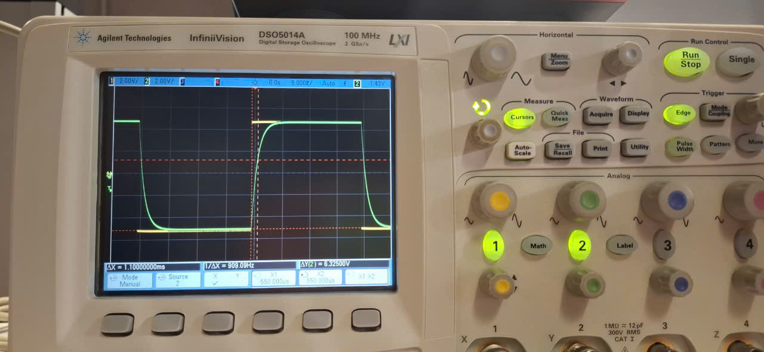

Figure 9

Figure 10

Figure 7: The signals recorded at the frequency f1 = 25 Hz

**Discussion:** The measured time constant on rising edge and falling edge is approximately equal to each other and equal to the calculated time constant τ from the values of the components.

1. Choose a positive square wave with a frequency significantly above the cut off frequency f = 900 Hz. The signals could be recorded as the figure 7 below.

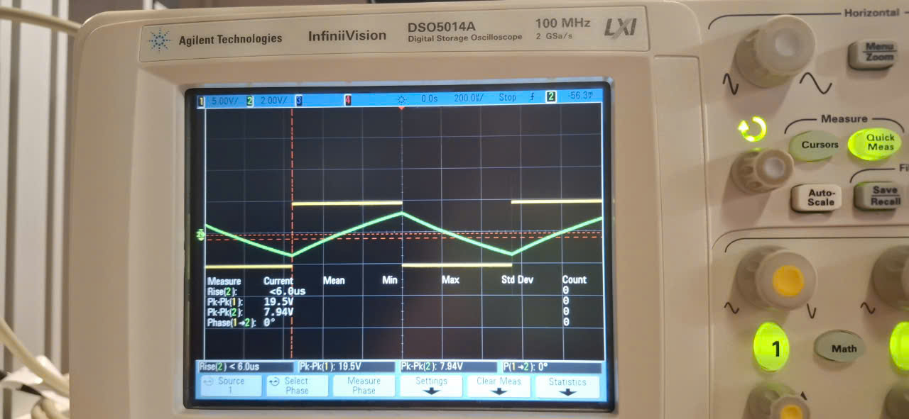

Figure 11

Figure 8: The signals recorded at the frequency f2 = 900 Hz

**Discussion:** From what was observed from the signals at the frequency f1= 25 Hz and f2 = 900 Hz, it can be concluded that the behavior of the output signal of Low Pass Filter in both of these cases are identical to each other. However, the time for charging at the frequency f2 = 900 Hz is shorter than the time for charging at the frequency f1 = 25 Hz. Therefore, the curve of the output signal at f2 = 900 Hz as the case in exercise 2a) is not demonstrated clearly in this experiment. Instead of that, the shape of the curve becomes aligned.

**Additional experiment:**  A triangular input wave (RAMP signal) is generated from the wave generator and connected to the circuit. As the result, the output signal is the signals having parabolic shape as the Figure 9 below.

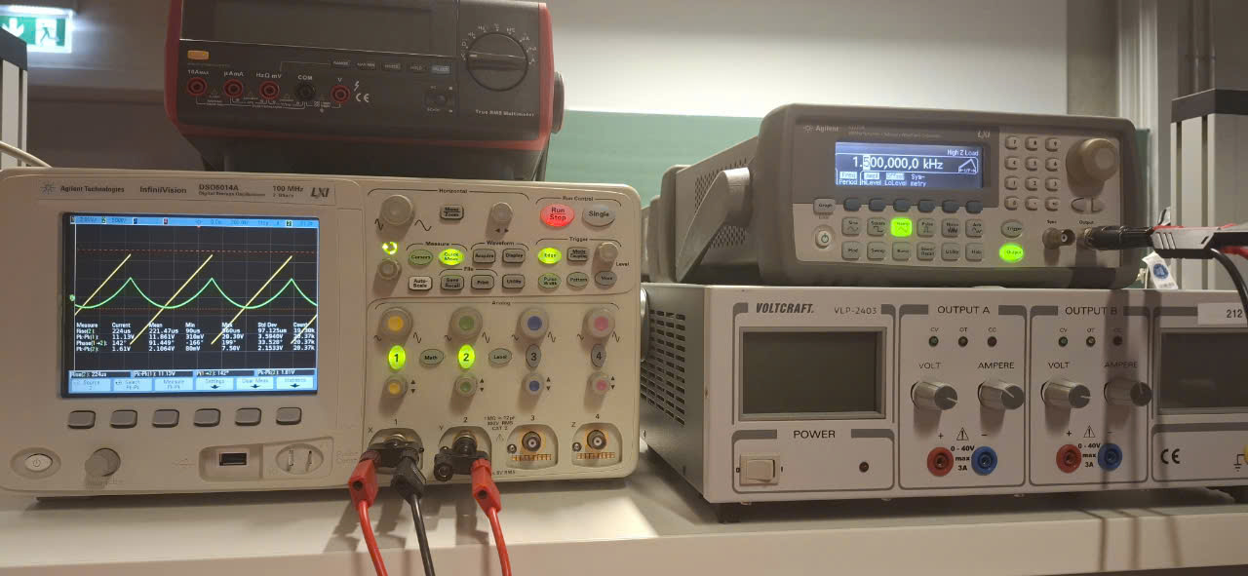

Figure 12

Figure 9: The output signal created from the RAMP input signal

**Discussion:** With RAMP signal, the charging speed of capacitor is increasing gradually, which create the parabolic shape in the figure 9 above.

As what can be seen in the figure 9, the yellow lines are the input signal y = a*x. The green lines are the output signals which are integrated from the input signals as the below formular:

Based on this formular, it can be explained why the output signal have the parabolic shape.

## **Measurement of experiment 3**

### **Description of experiment**

#### **Exercise 3 part a**

In the exercise 3-part a, the lab aims to analyzing the frequency response of an inverting operational amplifier circuit. Initially, an amplifier circuit is set up as Firgure 10, with resistor .

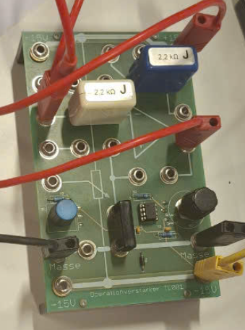 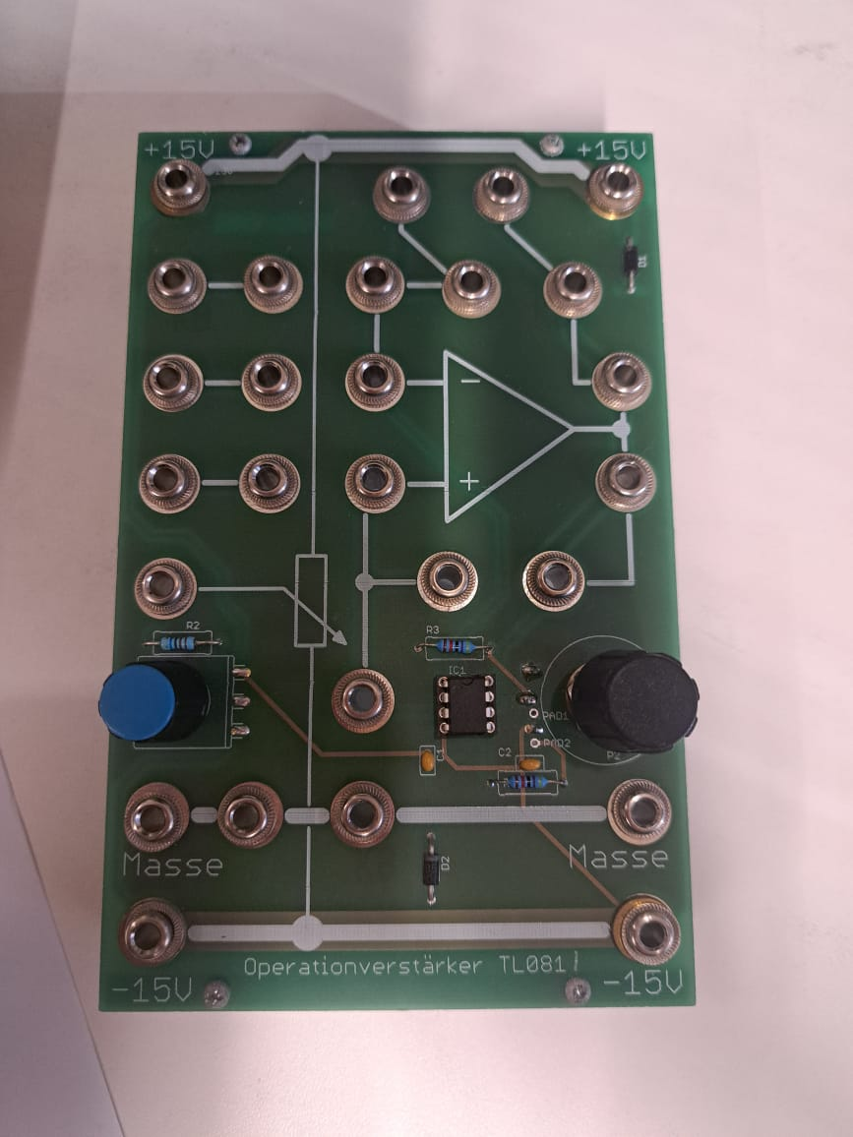

Figure 13

Figure 10 a) the lab set up for the amplifier circuit b) initial amplifier circuit

To creates a dual power supply with both positive and negative output voltages, a programmable power supply (PG) is used. This setup involves connecting the negative terminal of Channel 1 to the positive terminal of Channel 2, effectively creating a midpoint that serves as the reference or "ground" (masse). This configuration provides a power source with a range of ±15V, or other voltage levels depending on the PG settings. The positive terminal of Channel 1 is connected to the +15V input of the amplifier circuit, supplying the positive voltage. Similarly, the negative terminal of Channel 2 is connected to the −15V input of the amplifier circuit, supplying the negative voltage. The midpoint connection between the two channels is linked to the "masse" port of the amplifier circuit to establish a common ground. The set up for the lab is shown in figure bellow.

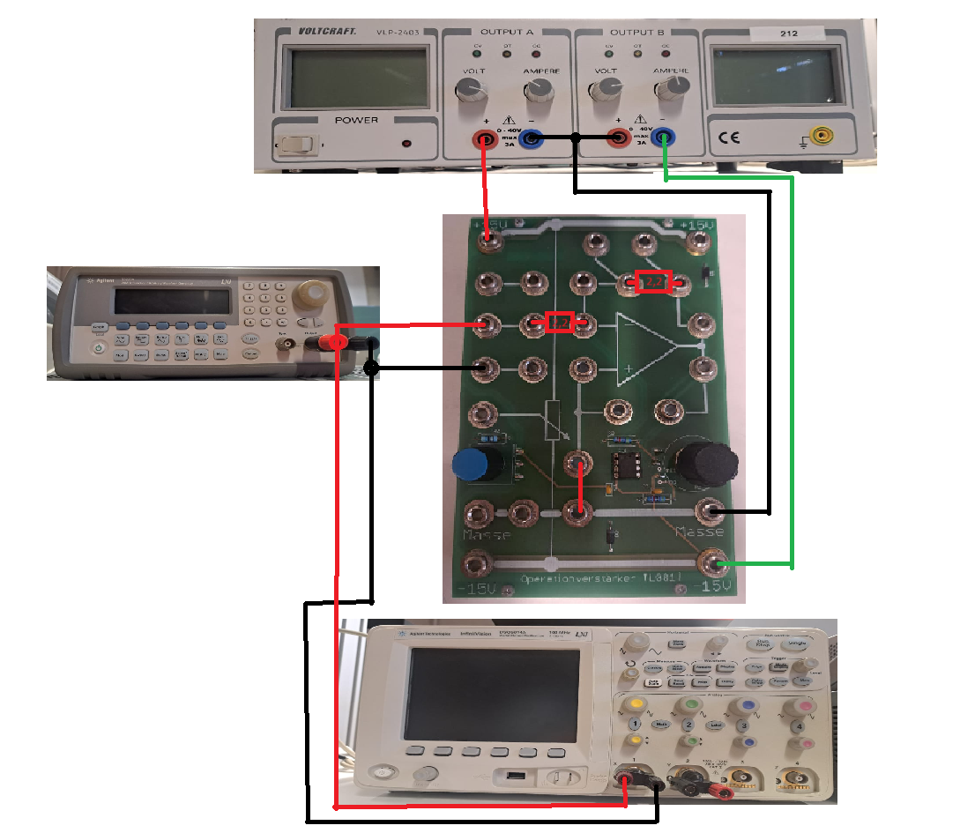

Figure 14

Figure 11: The lab set up

The measurement process mirrors that of Exercise 1. The wave generator provides varying frequencies and waveforms, while the oscilloscope captures input and output waveforms. Channel 1 connects to the wave generator and amplifier circuit input, and Channel 2 connects to the amplifier circuit output, with all grounds linked. A sine wave with a peak-to-peak amplitude of 10 V is applied at varying frequencies. The amplitude ratio is measured for specific values (1, 0.9, 0.8, etc.), along with the phase shift. Measurements continue until the amplitude ratio reaches the target thresholds. Results are plotted to illustrate amplitude ratio and phase shift versus frequency, determining the cut-off frequency (where amplitude is 70.7% of the input) and its corresponding phase shift, which are compared to theoretical predictions.

#### **Exercise 3 part b**

Repeating Exercise 3 Part a with a modification, the second resistor is replaced with instead of the original value. This change increases the gain of the inverting operational amplifier, which is determined by the ratio gain .

### **Results – diagram, table, graphics**

Table 4

|  |  |  |  |
| --- | --- | --- | --- |
| **Frequency f** |  |  | **A** |
| 10 Hz | 10 | 10 | 1 |
| 851 Hz | 9 | 0.9 |
| 951.570 kHz | 8 | 0.8 |
| 1.151570 MHz | 7 | 0.7 |
| 1.391570 MHz | 6 | 0.6 |
| 2.291570 MHz | 4 | 0.4 |
| 4.311570 MHz | 2 | 0.2 |

|  |  |
| --- | --- |
| Determined cut off frequency | 1.15157 MHz |

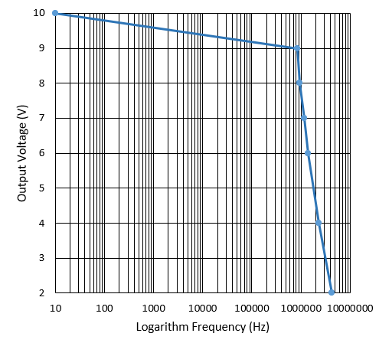

Table 5

Plot 3: Output voltage and Logarithm Frequency with

the cut off frequency

Table 6

|  |  |  |  |
| --- | --- | --- | --- |
| **Frequency f** |  |  | **A** |
| 1 Hz | 1 | 10 | 10 |
| 190.367 kHz | 9 | 9 |
| 290.367 kHz | 8 | 8 |
| 390.367 kHz | 7 | 7 |
| 510.367 kHz | 6 | 6 |
| 860.367 kHz | 4 | 4 |
| 1.720 MHz | 2 | 2 |
| Determined cut off frequency | | 390.367 kHz | |

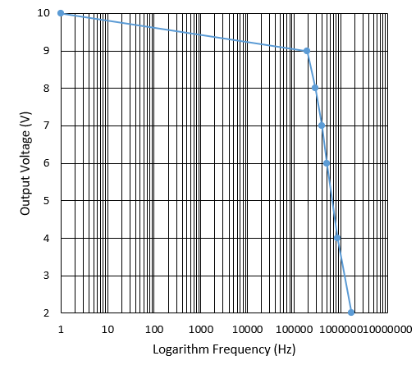

Figure 15

Plot 4: Output voltage and Logarithm Frequency with

the cut off frequency

### **Discussion of results**

Based on the data in the above tables, the op-amp which has the higher gain will have the smaller cut off frequency. With the gain value from 0.2 to 1, the frequency will fluctuate around the frequency 1 MHz, while the circuit which has the gain value higher than the circuit in the experiment 3a) 10 times from 2 to 10 will have the frequency around 500 kHz.

# **Summary and Outlook**

In the first and the second experiment, the behavior of Low Pass filter circuit can be observed through connecting wave generator to the circuit to generate the input signal (sine wave and square wave). More than that, by using the oscilloscope, the output voltage signal can be measured and observed. Therefore, the relationship between the frequency of input signal and the output voltage signal can be demonstrated. The wave signal observation illustrates the principle of Low Pass filter circuit. Similarly, in the experiment 3 the behavior of the inverting op-amp circuit is identical to the behavior of Low Pass Filter. However, the cut off frequency is much larger than the cut off frequency of Low Pass Filter. It can be concluded that although in the theory the ideal op-amp have cut off frequency, in reality when the frequency of input signal is too high, the op-amp cannot process output signal.

# **References**

1. Storr, W. (2024) *Low pass filter - passive RC filter tutorial*, *Basic Electronics Tutorials*. Available at: https://www.electronics-tutorials.ws/filter/filter_2.html (Accessed: 12 November 2024).
2. Nilsson, J.W. and Riedel, S.A. (2015) Electric Circuits. Boston: Pearson.
3. Storr, W. (2024a) Introduction to capacitors, capacitance and charge, Basic Electronics Tutorials. Available at: https://www.electronics-tutorials.ws/capacitor/cap_1.html (Accessed: 12 November 2024).
4. Storr, W. (2024c) Operational amplifier basics - op-amp tutorial, Basic Electronics Tutorials. Available at: https://www.electronics-tutorials.ws/opamp/opamp_1.html (Accessed: 12 November 2024).
5. Learn Electrical & Electronics Engineering (for free) (2024) Electrical4U. Available at: https://www.electrical4u.com/ (Accessed: 12 November 2024).
6. *Personalised learning* (no date) *BYJU’S*. Available at: https://byjus.com/ (Accessed: 12 November 2024).
7. Sedra, A.S. *et al.* (2021) *Microelectronic circuits*. New York: Oxford University Press.